Visual or Pictorial Dictionary

What is Visual / Pictorial Dictionary
# Source: AI Source: Provided by: [Data Path: Persons Table -> ID Column: 1, Name_En Column: Motasem Essam] -> From: [Chatgpt (GPT-4-turbo)] on [7/29/2025]
A Visual Dictionary (also known as a Pictorial Dictionary) uses images, diagrams, or illustrations to define and explain words—especially concrete nouns and technical objects. It’s ideal for learners, children, and professionals who benefit from visual learning or need to understand complex structures through images.

🔹 Key Features of a Visual / Pictorial Dictionary
# Source: AI Source: Provided by: [Data Path: Persons Table -> ID Column: 1, Name_En Column: Motasem Essam] -> From: [Chatgpt (GPT-4-turbo)] on [7/29/2025]
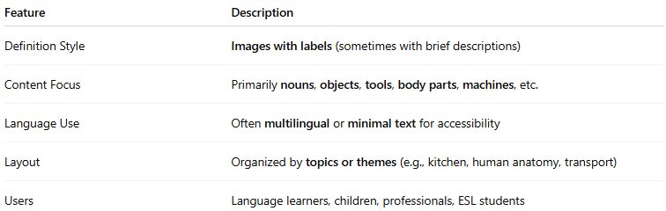
Feature | Description
Definition Style | Images with labels (sometimes with brief descriptions)
Content Focus | Primarily nouns, objects, tools, body parts, machines, etc.
Language Use | Often multilingual or minimal text for accessibility
Layout | Organized by topics or themes (e.g., kitchen, human anatomy, transport)
Users | Language learners, children, professionals, ESL students

🔹 Examples of Visual / Pictorial Dictionaries
# Source: AI Source: Provided by: [Data Path: Persons Table -> ID Column: 1, Name_En Column: Motasem Essam] -> From: [Chatgpt (GPT-4-turbo)] on [7/29/2025]
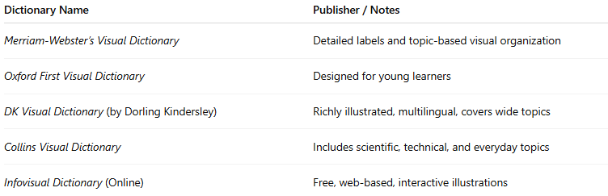
Dictionary Name | Publisher / Notes
Merriam-Webster’s Visual Dictionary | Detailed labels and topic-based visual organization
Oxford First Visual Dictionary | Designed for young learners
DK Visual Dictionary (by Dorling Kindersley) | Richly illustrated, multilingual, covers wide topics
Collins Visual Dictionary | Includes scientific, technical, and everyday topics
Infovisual Dictionary (Online) | Free, web-based, interactive illustrations

🔹 Advantages
# Source: AI Source: Provided by: [Data Path: Persons Table -> ID Column: 1, Name_En Column: Motasem Essam] -> From: [Chatgpt (GPT-4-turbo)] on [7/29/2025]
- Aids in vocabulary acquisition through visual memory
- Useful for cross-linguistic communication (e.g., travelers, refugees)
- Enhances understanding of technical or complex concepts
- Ideal for children or visual/spatial learners

🔹 Use Cases
# Source: AI Source: Provided by: [Data Path: Persons Table -> ID Column: 1, Name_En Column: Motasem Essam] -> From: [Chatgpt (GPT-4-turbo)] on [7/29/2025]
- Early language education
- ESL/EFL instruction
- Multilingual signage or training
- Field-specific training manuals (e.g., anatomy, tools, aviation)

